# Assignment 6 Name______Aaron Henderson_

**OPTION 1 – Real Estate Company**

1. Your target for this assignment is to design a simple web page for a local start-up real estate company.

They want the design of their web page similar to the following screenshot.

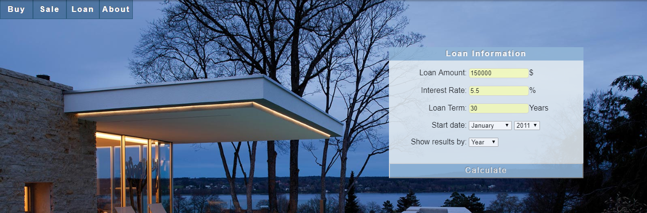

When user clicks the Loan Calculator link, the loan calculator will be displayed on the right side of the page. The Loan Calculator will calculate monthly payment with amortization schedule as follows.

Monthly interest rate = Interest rate(annual) / 12

Monthly Payment =LoanAmount × (M𝑜𝑛𝑡ℎ𝑙𝑦 𝑖𝑛𝑡𝑒𝑟𝑒𝑠𝑡 𝑟𝑎𝑡𝑒)/(1−(1+M𝑜𝑛𝑡ℎ𝑙𝑦 𝑖𝑛𝑡𝑒𝑟𝑒𝑠𝑡 𝑟𝑎𝑡𝑒)^(−𝑛𝑢𝑚𝑏𝑒𝑟 𝑜𝑓 𝑚𝑜𝑛𝑡ℎ))

Interest Paid Per Month = Balance x Monthly interest rate

Principal Paid Per Month = Monthly Payment – Interest Paid Per Month

Test Data with 150000 loan , 5.5% interest rate and 30 years term

Monthly Payment: 851.68

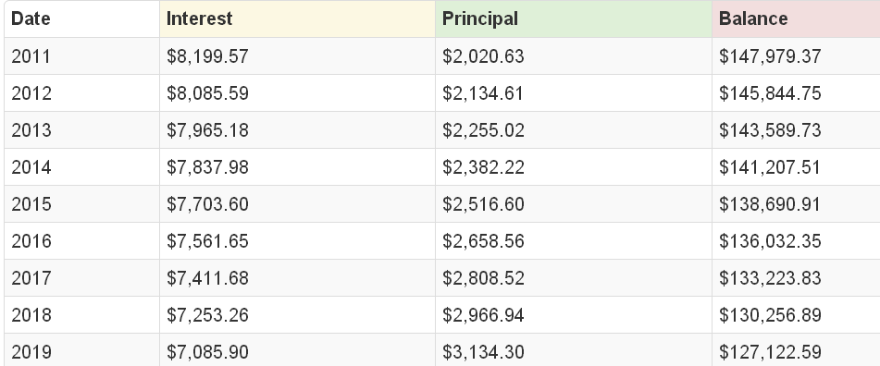

1. Here are grading rubrics/specifications for this assignment.

* Name your file - realestate.html
* In the assignment section of your index.html document, create a link which links to this document “realestate.html”.
* Click link and the loan calculator become visible.
* Loan Calculator interface
  + Input text box for Loan amount
  + Input text box for Interest rate(annual)
  + Input text box for Loan term(in Years)
  + Start year
  + Button “Calculate”
* JavaScript function for Loan Calculator
  + Read Inputs
  + Validate the inputs
  + Calculate monthly payment
  + Use for loop
    - Calculate annual interest and principal paid
    - Generate the table and display the amortization schedule as the above figure.
    - Hint: You need nested loop to work on this assignment. To calculate annual interest , you need to calculate interest month by month and then add them.
    - Hint: Use JavaScript Math.pow(x,y) function to calculate x^y.
* Before you submit your file, be sure to check this checklist.
* To submit:
  + Push all files, images to GitHub pages.
  + Click the submit button in blackboard.

**OPTION 2 – Local Auto Service Company**

1. You are asked by a local auto service company to convert the following diagnostic flowchart for a car that won't start or stalls to an interactive quiz. This JavaScript based interactive tool will help customer solve the car start problem. Please follow the **carcannotstart.mp4 video** to design and implement your easy to follow diagnostic quiz. All the situations in the flowchart need to be included.

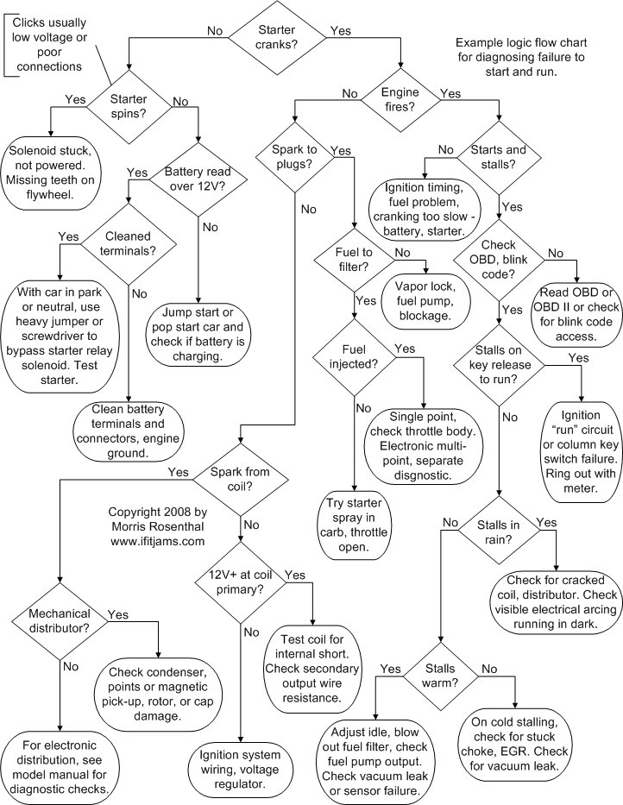

Copyright 2016 by Morris Rosenthal All Rights Reserved ---SOURCE: https://www.ifitjams.com/starting.htm

Please remember to put a reminder in your website that your interactive quiz is based on the flowchart created by Morris Rosenthal.